Multiple choice. Circle one answer only. If you change your answer make clear what your final choice is (2 points each).

- The figure to the right shows a molecule that will be most abundant in which of the following?
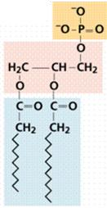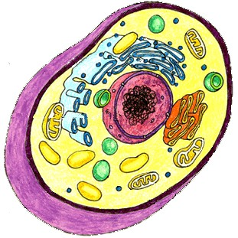
a)

b)

c)

d)

e)

- In the same diagram of the cell above, which organelle conducts mainly anabolic reactions?

  - A c) C e) E

  - B d) D
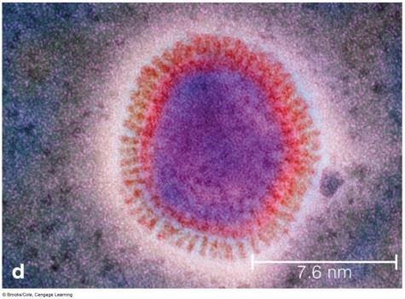
- Chemically speaking, the structure pointed by the arrow in this picture will resemble most closely this structure from the illustration in question 1:

  - A c) C e) E

  - B d) D

- One of the differences between a vaccinated and an unvaccinated person is that when both come in contact with the same pathogen, the vaccinated person:

  - Produces antigens rapidly d) Produces more types of lymphocytes

  - Produces antibodies rapidly e) Produces interferons

  - Produces antigens more slowly
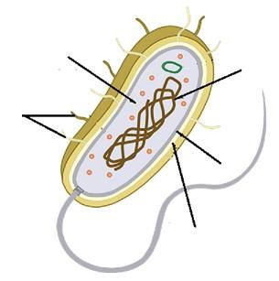
- Which of the structures labeled on the diagram to the right will be responsible for the outcome of a gram stain?
A

B

C

D

E

  - A c) C e) E

  - B d) D

- Metabolism is:

  - The ability of DNA to divide

  - Complexity in metabolic reactions

  - Maintenance of an organism’s internal environment

  - Adaptation to extreme temperatures

  - The sum of all chemical reactions occurring inside an organism

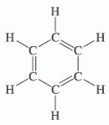
- How many types of bonds are there in the molecule shown on the right?

  - 1 c) 6 e) 12

  - 2 d) 9

- Which of these illustrates structure-function relations?

  - All animals have the same proteins

  - The molecular bonds in cellulose allow it to provide support to plants

  - All organisms can inherit traits from their parents

  - Energy can only flow through ecosystems

  - All of the above

- The virus that causes the common cold has this in common with HIV, the virus that causes AIDS:

  - Envelope c) RNA e) All of the above

  - DNA d) Capsid

- In a sense, the origin of Cell Theory is an example of:

  - Data mining c) Inductive reasoning e) Deductive reasoning

  - Technological advance d) An emergent property

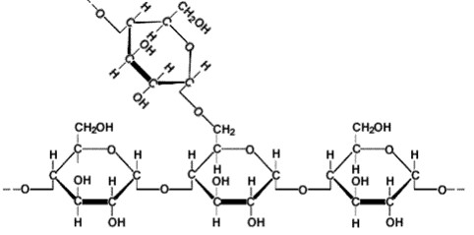
- The molecule on the right belongs to this general group of organic compounds:

  - Sugars c) Fats e) Proteins

  - Steroids d) Nucleic acids

- What property of the molecule in the previous question allows it to serve as energy storage?

  - Being an organic compound c) The bonds e) The phosphate groups

  - The carbon skeleton d) The ATP

- When you eat a pizza, most of the energy contained in the food:

  - Is specifically contained within the ATP of the pizza.

  - Gets recycled as glycogen.

  - Ends up flowing through the environment as heat.

  - Gets used as lipids in your mitochondria.

  - Is broken down by digestive enzymes in your stomach.

- Most of the nitrogen in the same pizza ends up as:

  - Proteins in your body.

  - Lost in digestion because it is contained in indigestible cellulose.

  - Stored as fats in your cell vacuoles.

  - Part of cholesterol in your cell membranes.

  - Lost to the environment through various metabolic processes.

- This is an example of a multicellular microscopic organism:

  - Archaea c) Chicken egg e) Rotifer

  - Acetabularia d) Bacteriun

- Draw the expanded molecular structure (showing all the atoms that comprise it) of the abbreviated structure below. For the OH groups (which are called carboxyl groups, in case you are curious), the oxygen can form only two covalent bonds. What is the name of this molecule (10 points):

OH

OH

OH

OH

OH

Bonus
- Why does a carboxyl group only react with an amino group when a cell is making a protein (hint: think of the chemical changes that happen)? (5 points)

